December 10, 2018

Melissa Wind
Development Director
Children’s Law Center of Minnesota
450 Syndicate St. N., Suite 315
St. Paul, MN 55104-4106
mwind@clcmn.org

Dear Melissa Wind:

Thank you for your application to the Wells Foundation requesting funding to support ongoing operations and increased capacity for legal services. Although impressed by your organization, after careful consideration the Board has declined your funding request.

Your organization’s work in addressing community issues is important and admirable. Unfortunately, we received requests far in excess of our available funds leading to difficult decisions.

We appreciate the time and effort expended in preparing the application, and wish you the best with your program. Please feel free to contact me if you have any questions about our decision.
Sincerely,
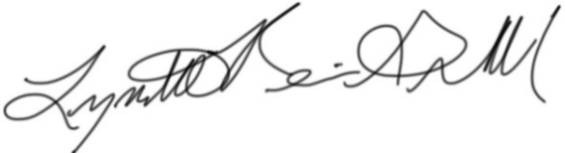
Lynette Reini-Grandell
Grants Committee Chair
grants@wellsfound.org

