December 10, 2018

Edith Kadlec, Development Officer
St. Stephen’s Human Services, Inc.
2309 Nicollet Ave. S.
Minneapolis, MN 55404
grants@ststephensmpls.org

RE: 2018 Grant Request

Dear Edith Kadlec:

I am pleased to inform you that the Wells Foundation has approved a grant of $6600 to help support your Street Outreach team working with people experiencing homelessness.

The funds will be sent by check from Wells Fargo bank sometime in January of 2019. Please be aware that as part of our funding process, we ask recipients to provide us with a status update within the year after receiving the funds and prior to submitting any additional funding requests. This update must include the following information:

- How funds were used
- Whether the total amount awarded has been used
- Any changes in the program structure since the time of application
- A brief summary of qualitative outcomes
- Data indicating quantitative outcomes

The Wells Foundation may also request a site visit to see the program in action. In addition, we also ask that you use our name, Wells Foundation, in all material referring to us as a grant source or benefactor and that you provide a link from your website to our website: www.wellsfound.org.

If you have any other questions about this grant, feel free to contact me. Otherwise, please accept our best wishes in carrying out this important work. Thank you.

Sincerely,
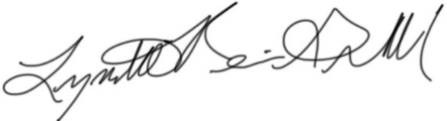
Lynette Reini-Grandell
Grants Committee Chair
grants@wellsfound.org

