December 18, 2017

Shawn Morrison
Executive Director
Good in the ‘Hood
1630 E. 90th Street
Bloomington, MN 55425
shawn@goodinthehood.org

Dear Shawn Morrison:

Thank you for your application to the Wells Foundation requesting funding for general operating support. Although impressed by your organization, after careful consideration the Board has declined your funding request.

Your organization’s work in addressing community issues is important and admirable. Unfortunately, we received requests far in excess of our available funds leading to difficult decisions.

We appreciate the time and effort expended in preparing the application, and wish you the best with your program. Please feel free to contact me if you have any questions about our decision.
Sincerely,
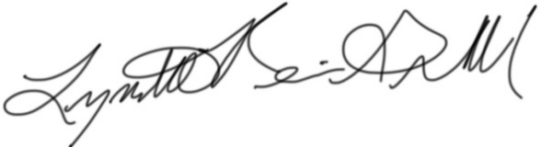
Lynette Reini-Grandell
Grants Committee Chair
grants@wellsfound.org

