December 18, 2017

Mike Manhard
Executive Director
MESH (Metro-wide Engagement on Shelter and Housing)
740 E. 17th Street
Minneapolis, MN 55404
mike@mesh-mn.org

Dear Mike Manhard:

Thank you for your application to the Wells Foundation requesting funding to secure a matching amount from a challenge grant from the Otto Bremer Foundation that will enable MESH to work with communities across Minnesota to enhance and expand their ability to prevent and end homelessness. Although impressed by your organization, after careful consideration the Board has declined your funding request.

Your organization’s work in addressing community issues is important and admirable. Unfortunately, we received requests far in excess of our available funds leading to difficult decisions.

We appreciate the time and effort expended in preparing the application, and wish you the best with your program. Please feel free to contact me if you have any questions about our decision.
Sincerely,
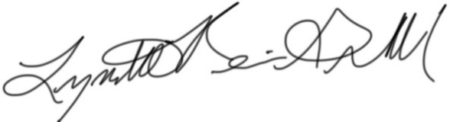
Lynette Reini-Grandell
Grants Committee Chair
grants@wellsfound.org

