December 10, 2018

Maggie Haley, Grants Manager
Project for Pride in Living, Inc.
1035 East Franklin Avenue
Minneapolis, MN 55404
maggie.haley@ppl-inc.org

RE: 2018 Grant Request

Dear Maggie Haley:

I am pleased to inform you that the Wells Foundation has approved a grant of $5000 for Family Support Services at Camden Apartments in north Minneapolis.

The funds will be sent by check from Wells Fargo bank sometime in January of 2019. Please be aware that as part of our funding process, we ask recipients to provide us with a status update within the year after receiving the funds and prior to submitting any additional funding requests. This update must include the following information:

- How funds were used
- Whether the total amount awarded has been used
- Any changes in the program structure since the time of application
- A brief summary of qualitative outcomes
- Data indicating quantitative outcomes

The Wells Foundation may also request a site visit to see the program in action. In addition, we also ask that you use our name, Wells Foundation, in all material referring to us as a grant source or benefactor and that you provide a link from your website to our website: www.wellsfound.org.

If you have any other questions about this grant, feel free to contact me. Otherwise, please accept our best wishes in carrying out this important work. Thank you.

Sincerely,
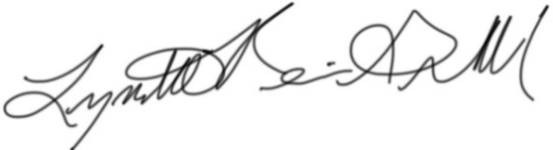
Lynette Reini-Grandell
Grants Committee Chair
grants@wellsfound.org

